Name :- Lalit singh

Course :- BCA

Subject :-Web Development

Std id :- 20041209

Roll no :- 2092027

Practical - 07

**Objective:** To show the inputs of html forms through php.

**HTML CODE:**

<!DOCTYPE html>

<html lang="en">

<head>

<meta charset="UTF-8">

<meta http-equiv="X-UA-Compatible" content="IE=edge">

<meta name="viewport" content="width=device-width, initial-scale=1.0">

<title>Document</title>

<style>

*{

padding: 0;

margin: 0;

background: #ffffff;

color: rgb(0, 0, 0);

}

h1, form{

padding:10px;

margin: 10px;

text-align: center;

}

.btn{

margin: 10px;

background: #e32f2f;

padding: 5px 10px;

border-radius: 4px;

}

</style>

</head>

<body>

<h1>registeration</h1>

<form action="abc.php" method="GET" name="form" >

enter the name <input type="text" name="dsg1" placeholder="lalit"><br><br>

enter the age <input type="text" name="age" placeholder="20"> <br>

<input type="submit" value="send" class="btn">

</form>

</body>

</html>

**PHP CODE :-**

<!DOCTYPE html>

<html lang="en">

<head>

<meta charset="UTF-8">

<meta http-equiv="X-UA-Compatible" content="IE=edge">

<meta name="viewport" content="width=device-width, initial-scale=1.0">

<title>Document</title>

</head>

<body>

<h1>results are</h1>

<?php

echo"name is " .$_GET["dsg1"] ."<br>";

echo"age is " .$_GET["age"]."<br>";

?>

</body>

</html>

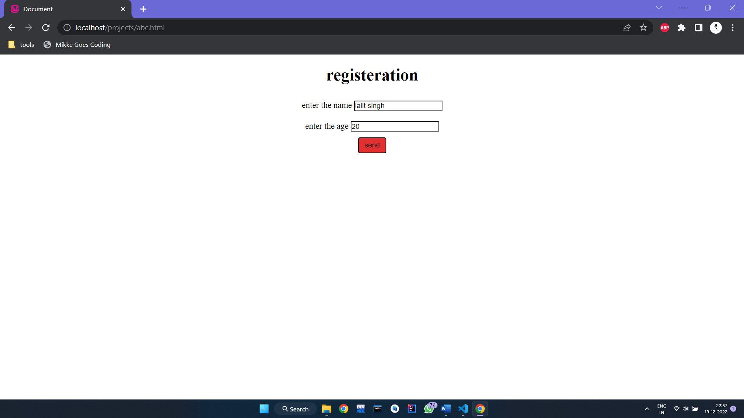**OUTPUT: -**

